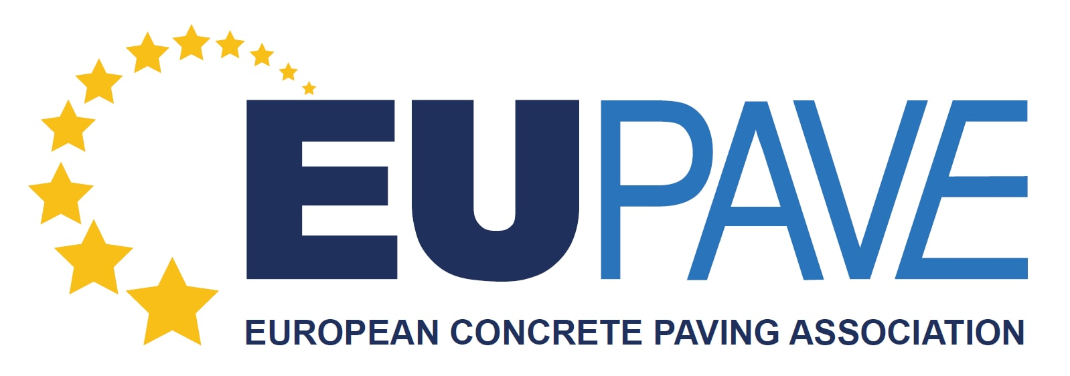

REGISTRATION FORM

Marc Tarabella, MEP, and the European Concrete Paving Association, EUPAVE, invite you to

Breakfast Debate on “Tendering for sustainable infrastructure in the circular economy”

Date: Wednesday, 17 October 2018
Hour: 7.45 - 9.30 am Registration at 7.45, event starts at 8.15 sharp
Venue: Altiero Spinelli building, ASP0G, MEP Salon, European Parliamant, Brussels
60 rue Wiertz / Wiertzstraat 60, 1000 Bruxelles/Brussels

Name First name

Position Organisation

Email address

If you do not already have a badge to access the European Parliament, please fill the information below and
attached a copy of your ID document.

Date of birth

Nationality

ID number

Please email the registration form filled to e.carabedian@eupave.eu by Monday 1st October

