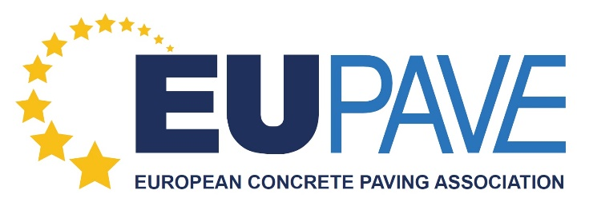

AFFILIATION FORM

INVOICING INFORMATION:

Company/Association’s name (in full & correct spelling):

......................................................................................................................

Full address: ......................................................................................................................
......................................................................................................................
......................................................................................................................

Website: ......................................................................................................................

Contact person: .....................................................................................................................

VAT number: ......................................................................................................................

E-mail: ......................................................................................................................

Type of affiliation requested: Full Member / Associate Member / Partner

Date: ......................................................................................................................

Please send the form filled to Ms. Elise Carabédian, e.carabedian@eupave.eu

EUPAVE
Vorstlaan 68, Bd du Souverain – B13
1170 BRUSSELS – BELGIUM
TEL +32 (0)2 645 52 31
E-mail: info@eupave.eu www.eupave.eu

