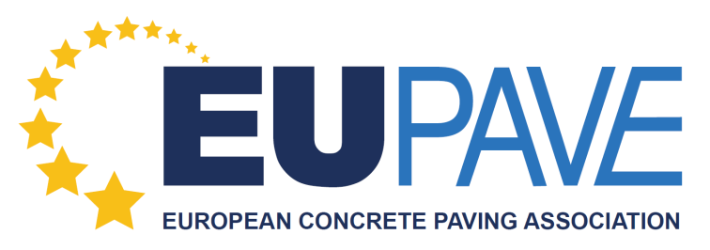

MEMBERSHIP/PARTNERSHIP REGISTRATION FORM

INVOICING INFORMATION:

Company/Association’s name (in full & correct spelling):

Full address:

Website:

Contact person:

VAT number:

E-mail:

Type of Membership requested: Full Member

Date:

Please send the form filled to Ms. Elise Carabédian, e.carabedian@eupave.eu

